**Sprint 1 - Personal portfolio**

Group 28

**Jayden Dao – n10003665**

<https://github.com/gaffnni/IFB299_TuttingTrumpets>

Due Date: 4 May, 2018

**Artifact 1 - Business Plan Model and Notation**

Have produced Business plan model and notation constructs the process of the client. This goes through the process of client navigating to the site and going through registration process which would then be able to learn an instrument. The BPMN show how each process would be conducted to create a natural flow of the website structure.

This allowed the team to better understand usages of the website from another perspective. It would help members of the team layout the sites structure for a more user-friendly experience. This goes forward to improving system design and business process.

Below is an sample of the BPMN diagram which describes a client registration process:

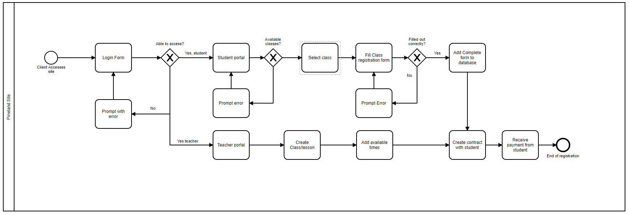

**Artifact 2 - Colour scheme and background images**

The Colour scheme is used to unify the website design to make the overall site more user friendly. This consists of matching colours alongside each other. Also, have indicated the text font choice and look of the button with matching colours with each other. After deciding on the colour style it was a matter of adapting these colours into the site.

This project would help team members adape these colours to a CSS for a universal style surrounding the website. This was useful for team members working on the website as each page, text and button followed a similar colour scheme. It allowed all the pages follow a similar style sheet which would increase work flow and presentation style.

An Example of the colour scheme

|  |  |  |  |
| --- | --- | --- | --- |
| #424242 | #95c079 | #cde1cc | #eff9f4 |
|  |  |  |  |

Sample of background being used on the site

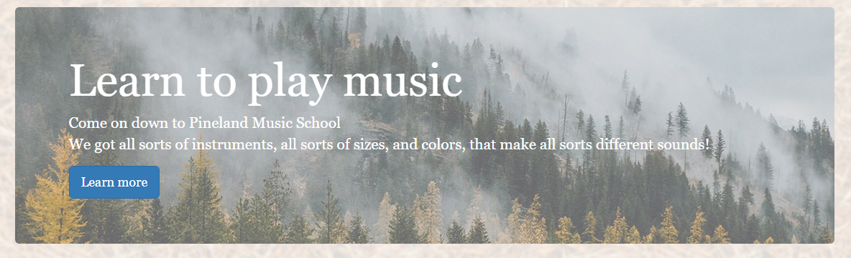

**Artifact 3 - Logo**

Several attempts and redesigns have been reproduced to create the ideal design to best integrate the name and theme into the logo. This consisted of multipal sketches while communicating with team members for feedback. Logo was created using photoshop and silhouette images to integrate both music and pine trees. The target audience was directed towards a sophisticated demographic while also maintain transparency for a wide range of students.

This allowed the team to better understand the theme of Pineland Music school as it has been created to imply a profession look. The logo has been created with multiple variances to fit any area of the website. Each layer was saved individually so changes can be easily modified in the future when needed.

Below are examples of the process and where it is used on the website:

|  |  |  |
| --- | --- | --- |
| Planning Stage | Design Concept | Final Logo |

Sample of Logo being used on the site:

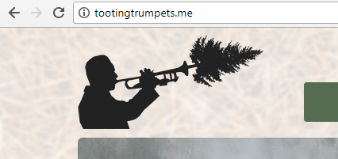

**Artifact 4 - HTML pages**

I have coded the Teacher registration, Teacher Classes and Student Available Classes for the website. This is comprised with adapting bootstrap formatting alongside html code to produce pages which work alongside SQL. Teacher Classes and Student Available Classes comprised of table with an ‘#ID’ to help fields to present information stored from the database. Teacher Registration required a form to be filled out and save information to the database.

This helped the team build the database and attach it with the forms to create a functional website. Having this functionality would further extend members working on the database able to test the functionality and user experience.

This example shows the coding for the Teacher registration:

|  |
| --- |
| <?php  $basename = 'Teacher Registration';  $form = 'teacherregform';  require_once("../../../resources/config.php");  require_once(TEMPLATES_PATH . "/header.php");  require_once(TEMPLATES_PATH . "/banner.php");  require_once(LIBRARIES_PATH . "/registerfunc.php");  require_once(TEMPLATES_PATH . $_SESSION["user"][3]);  ?>  <div class="container">  <form action="<?php echo htmlspecialchars($_SERVER["PHP_SELF"]);?>" name="regform" method="POST" id="regform">  <div class="col-md-6">  <div class="panel">  <div class="panel-heading">  <h3 class="panel-title">Teachers Information</h3>  </div>  <div class="panel-body" >  <table class="table">  <tbody>  <tr>  <td id="cellleft">First Name :</td>  <td id="cellright"><input required type="text" name="firstname" placeholder="Given Names"></td>  </tr>  <tr>  <td id="cellleft">Last Name :</td>  <td id="cellright"><input required type="text" placeholder="Family Name" name="lastname"></td>  </tr>  <tr>  <td id="cellleft">Username :</td>  <td id="cellright"> <input required type="username" name="username" placeholder="Username"></td>  </tr>  <tr>  <td id="cellleft">Password :</td>  <td id="cellright"> <input required type="password" name="password" placeholder="Password"></td>  </tr>  <tr>  <td id="cellleft">Date of Birth :<br><p class="text-muted"> Under 18 will be required</br>to give parent information<p></td>  <td id="cellright"><input required type="date" class="bday" name="dob"></td>  </tr>  <tr>  <td id="cellleft">Address :</td>  <td id="cellright"><textarea required rows="4" cols="30" placeholder="" name="address"></textarea></td>  </tr>  <tr>  <td id="cellleft">Gender :</td>  <td id="cellright"><input type="radio" name="gender" value="male"> Male<br>  <input type="radio" name="gender" value="female"> Female<br>  <input type="radio" name="gender" value="other"> Other </td>  </tr>  <tr>  <td id="cellleft">Phone Number :</td>  <td id="cellright"><input required type="tel" name="mobphone" placeholder="Phone Number"></td>  </tr>  <tr>  <td id="cellleft">Email :</td>  <td id="cellright"><input required type="email" name="email" placeholder="Email"></td>  </tr>  <tr>  <td id="cellleft">Language :</td>  <td id="cellright"> <select>  <!-- Will change to list all available in DB !-->  <option value="" disabled selected>Select</option>  <option value="english">English</option>  <option value="Spanish">Spanish</option>  <option value="french">French</option>  <option value="mandarin">Mandarin</option>  <option value="arabic">Arabic</option>  </select> </td>  </tr>  <tr>  <td id="cellleft">Instruments :</td>  <td id="cellright"> <select>  <!-- Will change to list all available in DB !-->  <option value="" disabled selected>Select</option>  <option value="saxophone">Saxophone</option>  <option value="trumpet">Trumpet</option>  <option value="marrccas">Marrccas</option>  <option value="triangle">Triangle</option>  </select> </td>  </tr>  </tbody>  </table>  <input type="submit" class="btn btn-primary" value="submit" form="regform">  </div>  </div>  </div>  <div class="col-md-6">  <div class="panel">  <div class="panel-body" style="padding-top: 75px">  <img src="img/logo.jpg" height=100% width=100% style="border: 2px solid black">  </div>  </div>  </div>  </form>  </div>  <?php  require_once(TEMPLATES_PATH . "/footer.php");  ?> |

**Artifact 5 - Meeting logs**

Meeting logs indicate the overall progress and help keep track of tasks completed and upcoming project. This is a tracker of all the team meetings with content which was discussed. The log will continue to expand further down the project.

This helps the team keep track of the overall projects direction and a performance indicator. It also identifies areas which could be improved and make sure all areas of the case study are complete. As a result, Team members has been provided with a clear understanding for the requirements for the project.

The meeting log is shown as follows:

|  |  |  |
| --- | --- | --- |
| **Date** | **Meetings** | **Content Coved** |
| 2 May | Week 8 tut | Sprint 1 personal portfolios |
| 18 April | Week 7 tut | Worked on sprint 1 releases. |
| 28 March | Week 6 tut | Finalize submission and discuss work over the holiday |
| 24 March | Meeting for 3 hours | Refine user stories and release & sprint planning before submission |
| 21 March | Week 5 tut | Improve user stories and discussed sprint planning |
| 16 March | Meeting for 2 hours | Discussed component to the sprint planning |
| 14 March | Week 4 tut | Layout user stories and checked all project case studies were included |
| 7 March | Week 3 tut | Dissected and understand Project Case study |
| 28 Feb | Week 2 tut | Created and accepted team agreement |
| 21 Feb | Week 1 tut | Understand each other’s strength and weaknesses and established a name, ‘Tooting Trumpets’ |